“If You Don’t Migrate, You’re a Nobody”:
Aspirations, Experiences and Migration Networks of the Nepalese Farm Workers in Portugal

Abstract
This paper analyses the aspirations, experiences and networks of Nepalese workers in Southern Portugal farms and greenhouses. By highlighting the perspective of the migrants, we examine the impact of the migration experience and large sums paid to smugglers (usually obtained as debt) to enter Portugal in their lives. We relate those experiences to a context of immigration where the existence of a large informal labour market facilitates their hiring as irregular migrants.
We used ethnography comprising of participant observation and semi-structured interviews. Thirty-eight interviews of Nepalese agriculture workers, Nepalese and Portuguese recruiters, Portuguese farm managers and farm owners were conducted in 2017 and 2018.
Our main finding is that their predisposition to migrate tends to be reinforced by the role of recruiting networks. Secondly, we show that changes in migration policies played a role in the recent inflow of Nepalese migrants in Portugal – barriers raised in 2011 by the United Kingdom to the contracting of immigrants from outside the EU led the smugglers to look for alternatives in other European countries. Lastly, the downsides of their migration are naturalised: both the costs of migration and labour exploitation are perceived by the workers as normal even if unexpected.
(197 words)

Keywords
Undocumented migrants, recruitment, aspirations, Nepalese, migration and agriculture, Portugal

Highlights
- The Nepalese interviewed revealed that the economic reason to migrate is socially oriented, in the sense that in addition to material gains, they aspired to migrate to have their social status risen in Nepal, related to the expectation of success.
- Most of the Nepalese workers interviewed had made the journey to Portugal by contracting formal networks, i.e., intermediary recruitment agencies.
- We assessed that due to the pan-EU migration restrictive policies towards non-EU immigrants, many Nepalese resort to illegal smuggling, ending up paying on an average €9,500 to recruitment and travel agencies, to be able to work in agriculture in Portugal.
- The decrease of non-EU immigration to the UK, the former top destination of Nepalese in Europe, due to restrictive immigration policies in 2011, is directly related with the following increase of the Nepalese inflow into Portugal in the same time period.
- Due to the obstacles to get a work Visa to migrate directly from Nepal to Portugal, the Nepalese enter the country after migrating in-between through three main routes: Poland, Latvia and Turkey.
- The Nepalese enjoy consuming the “modernity” in Portugal, e.g., concerning the way of dressing, as well as a new lifestyle where they enjoy more freedom compared to Nepal.
- Their aspirations to migrate for a better life and the restrictive immigration policies contributes to naturalise the debts contracted for migration and labour exploitation.

1. Introduction
“How much did you pay to come to Portugal?” was a recurring question Nepalese agricultural workers posed the Nepalese researcher at the beginning of the interviews. She would answer, “I didn’t pay anything, I came here with a scholarship to study”. Startled, they would ask: “And they gave you a visa? Didn’t you have to pay for it to an agency?”. She would respond “no” and then they willingly share that they had to pay about 10 thousand euros to get a visa to Portugal to work in the farms.
Nepalese migration to Portugal is a recent phenomenon in rapid expansion. In 2011, there were 1,145 Nepalese residing in Portugal while in 2018 there were already 11,489 (SEF 2012, 2019a). A significant proportion of them work in seasonal jobs of redberry fruit agriculture, in precarious accommodation and labour conditions. On the one hand they face unsurmountable bureaucratic difficulties from Portuguese authorities to obtain a visa to enter and work in Portugal in a regular way thus often becoming undocumented. On the other hand, the greenhouses need a large number of seasonal workers during a reduced number of months, exporting their produce to Northern and Central European markets, leading them to often hire undocumented migrant workers, given the absence of an interested national labour force. This trend fits into the context of the Southern European model of immigration where the existence of a large informal labour market facilitates their hiring as irregular migrants (King and DeBono 2013). Being relatively recent, the dynamics of the relationship between international migration and industrial agriculture is still understudied in Portugal (see however Moreno, Esteves, and Fonseca 2016; Taboadela, Maril, and Lamela 2018; Pereira et al. 2016; Morén-Alegret et al. 2018).
The main objective of this study is to analyse how informal and formal migration networks, particularly recruitment, originating from Nepal and targeting rural Portugal were established and have rapidly consolidated. Then it focuses on the relation of recruitment with immigration policies, articulating the aspirations and the experiences of Nepalese migrants both before and after their travel to Portugal. They study takes into account issues such as the debt situation migrants fall in to pay the intermediaries of their networks; the migration routes they use to reach their destination in Portugal and its relation with immigration policies; and the practicalities of their life as seasonal farming workers (namely their underemployment and constant risk of unemployment).
To study this topic comprehensively, a mix of methods was used. National and international statistical indicators on migration and remittances were analysed to contextualise the profiles of the Nepalese in Portugal. Complementarily, qualitative ethnographic methodology was employed comprising of participant observation and semi-structured interviews to characterise their migration processes. The interviews were conducted among Nepalese farm workers and their recruiters in Nepal. Portuguese greenhouse owners, managers and local recruiters were targeted to better understand the different perspectives concerning the Nepalese experience of migration and work in Portuguese industrial agriculture.
Our main finding is that migrants’ decision to migrate is strengthened by the role of the formal and informal recruitment networks. Secondly, we show that changes in migration policies have played a determining role in the recent inflow of Nepalese into Portugal – Great Britain had until 2011 been their traditional main European destination but a series of legal and administrative barriers raised that year by the UK authorities, effectively denied the entrance of new non-EU immigrants, which led both migrants and intermediaries to look for alternative European destinations. Lastly, the downsides of their migration have become naturalised: both the high costs of migration and the exploitative labour conditions tend to be perceived as “normal” by the interviewees.

2. Literature review
The phenomenon of large numbers of Nepalese workers in industrial agriculture in Portugal is quite recent and available research is scarce. To contextualise our topic, we briefly present the key literature on migrants working in agriculture in Southern Europe, and focus on the relation between the labour market conditions in Portugal and the increased numbers of immigrants in an irregular situation. Lastly, we discuss the changing patterns of Nepalese migration and extant research in Portugal.
Southern Europe has, since the 1980s, developed into a major global agricultural enclave competing with California and Latin America. Here agriculture presented similarities with global enclaves in other productive sectors, i.e., an exponential growth in trade that has increasingly internationalised and financialised various entrepreneurial networks, along with visible trends towards business concentration (cf. Taboadela, Maril, and Lamela 2018; Martin 2017). At the beginning of the 21st century, in Southern Italy, Southern Spain and Greece (but not in Portugal), the use of immigrant labour for seasonal harvesting in replacement of national workers was a fundamental feature of the Mediterranean-type agriculture, now transformed by new business models and farming technologies (Reyneri 2003, 123–24). In places where family, local and small-scale agriculture predominated, a new industrialised Mediterranean agriculture appeared, based on extensive productive areas and requiring international investment. The use of immigrant labour became an integral part of this new productive setting characterised by seasonal work imposing a continually precarious situation for the labourers: they were in constant transit and thus unable to settle in local communities on equal terms, as in Spain, Greece and Italy (Giménez Romero 1991; Kasimis 2005; Kilkey, Plomien, and Perrons 2014; Hoggart and Mendoza 2000).
In Portugal, family-based agriculture prevailed until the 1990’s, despite attempts from some international investment firms at establishing intensive greenhouses in Southern Portugal. It was only in the late 2000s that intensive agriculture directed to the international market and consequent hiring of immigrants took off; a first, smaller, wave consisting mainly of East Europeans (e.g., Ukrainians) was superseded by the arrival of South Asians (e.g., Nepalese and Thailandese), more willing to accept the trying conditions of underpaid seasonal labour. This topic being relatively recent received little attention from scholars (see however Moreno, Esteves, and Fonseca 2016; Taboadela, Maril, and Lamela 2018; Pereira et al. 2016; Morén-Alegret et al. 2018).
The informal segments of the labour market have paved the way for irregular immigrants to access jobs in intensive farming enterprises. And the growing need for seasonal farm workers became a pull factor for a growingly large number of irregular immigrants to work in the sector - a situation in tune with of the Southern European model of migration (King and DeBono 2013). Demand for a flexible labour force and the restrictive immigration policy has led to a situation in which the needs of the labour market colluded (even if involuntarily) with irregular migration channels and networks, i.e., those run by smugglers and traffickers (Peixoto 2009). This trend has been visible in the last two decades in sectors such as domestic work, industrial cleaning, old age caring and the sex industry (Peixoto 2009; Suleman and Figueiredo 2018). To these, seasonal labour in intensive agriculture has been belatedly added in the late 2000s, as mentioned. In Europe this trend is not exclusive to Southern countries: countries with stronger formal economies have also been affected by the recent influx of South Asian and East European migrants working in intensive agriculture, e.g. the Nordic countries and the UK. In common with those in Southern countries, these workers earn higher wages compared to their home countries and inattraction of the national workers to such jobs (Carmo and Hedberg 2019; Rye 2018).
The few studies on Nepalese immigrants in Portugal focus on gender, integration, parenthood and entrepreneurship (Bajracharya 2015; Branco 2015; Dahal 2016; Dangol 2015; Budal 2018; Pereira 2019; Maharjan 2018). As the migration journey is often made clandestinely, finding reliable information is difficult. Still, it seems clear that the financial costs and the risks involved in the process are high. Recent research has ascertained that Nepalese migrants pay to migrate to Qatar and that they pay an average of €13,600 to work in Japanese restaurants (Martin 2017; Kharel 2016). We found that €9,500 is the average cost of a journey from Nepal to Portugal through various routes. Although, by definition, the trafficking networks are clandestine, they sometimes come under the radar of the authorities: in 2018, one Portuguese and two Nepalese citizens were convicted for human trafficking in Portugal and 23 Nepalese victims were rescued (OTSH 2018). Besides the debts incurred to pay the traffickers and the risks involved in the migration process, irregular immigrants also share being undocumented as a major challenge to attain their self-admitted goal of family reunification in Portugal (Budal 2018). Given the social, economic and humanitarian impacts of this recent phenomenon, this study aims at showing that further research is needed to better understand the situation of Nepalese immigrants in Portugal, their experiences, aspirations and relations with the local communities.

3. Key theoretical concepts and issues
When studying migration, it is crucial to distinguish between initiation and reproduction (Massey 1993). Initiation presupposes the existence of a potential for emigration correlated with the recognition of socio-spatial inequality, but the realisation of this potential is counteracted, in particular, by lack of information and the insecurisation of migration for potential migrants. Events at origin or destination make it possible to unblock the obstacles to that achievement, and therefore, in the study of migrations “there is a need to distinguish between the genesis and the continuation of flows when assessing causation” (Salt, 1987: 242), and therefore to focus the analysis of the genesis of any migratory flow on the study of its specific historical context. As a rule, migration flows tend to have three main types of origin (Pires 2003, 77): (i) the slow accumulation of individual migratory movements between societies with long historical ties (Massey et al. 1993, 431–33; Portes 1999, 28) (ii) intensive and organised actions of recruitment of migrants that overcome the costs of information and insecurisation, as well as the economic and political constraints of displacement (Castles 2000, 61–71; Piore 1979, 19–25; Salt 1987, 242); (iii) and the occurrence of episodes of extensive and intensive social disorganisation in the areas of departure following disasters, deep economic crises, wars or revolutions (Goldin, Cameron, and Blarajan 2011).
Once migratory flows have been created, intra-migrant networks and those established between them and the societies of origin allow the self-sustained reproduction of these flows, especially when potential migrants have a range of links that, although weak at first, assure increased access to information on migratory opportunities (Granovetter 1973). Emigration then operates in a logic of self-sustaining cumulative causality (Massey et al. 1993; Portes 1999, 27), thereby reducing the initial costs of lack of information and insecurisation for migrants and enabling multiple motives to emigrate. Once migratory flows are solidified it is possible to build up family traditions of migration (Faist 2000, 159–60). These traditions can be strengthened as the flows stabilise, thanks especially to the circulation of information through migratory networks that foster the dissemination of over-represented images of the success of migrants in the collectivities of origin. The pull factors at the destination are thus subjectively magnified while the costs of integration tend to be neglected or outrightly omitted (Helweg 1987, 173). An individual migration decision process therefore incorporates not only a rational instrumental assessment but also a number of normative obligations towards the collectivity and the spread of cognitive beliefs (Boudon 2003) built on the representations of migration to which potential migrants have access and confidence.
Migration flows are sustained by social networks and tend to be selective at various levels. Firstly, there is a social dimension generally involving migrants of the same social origin making it more likely for them to be interrelated (Blau 1977). Secondly, there is a territorial dimension whereby the flow is often established between a restricted number of regions and localities of origin and a similarly small number of contingently-defined destinations (Faist 2000). And finally, the selectivity of flows is expressed at the occupational level: the networks tend to channel the flow not only socially and geographically but also occupationally, thus creating “occupational ethnic niches” born out of “initiatives taken by those who are already employed to bring others, from the same origin [...] to work with them” (Portes 1999, 34).
The creation of such ethnic occupational niches is facilitated by the dualisation of the labour market at the destination that operates by consecutive processes of segmentation through which migratory movements tend to accord with the statutory dynamics of the employment hierarchies (Piore 1979, 26–43). Low paid, precarious and often seasonal or ephemeral jobs that are not attractive to local communities, not only in financial but also in statutory terms, tend to be accepted by immigrants. In fact, in the early stages of the migration path, immigrants are more likely to favour strategies of saving and remitting these savings to the origin country, defining their jobs as a source of income rather than as a source of status, shifting the honourability of the position to the prestige that remittances would have in the societies of origin (Piore 1979, 52–59).
However, the prolongation of the migratory experience alters this availability for the temporal and spatial deferment of status considerations. The progressive assessment of social position by reference to social hierarchies at the destination and not at the origin induces a transformation of migrants' orientation, especially in cases of overqualification for the job. Aspirations for upward mobility that had been suspended in the first years of settlement at the destination starts emerging or gaining weight (Carling and Schewel 2017). Migrants' aspirations are hence updated or changed during the migration process, their expectations of social mobility increase and any experienced frustration of these new goals may be at the origin of negative evaluations of their overall experience. Studies widely show the feeling of success or failure of individuals depend more on the accomplishment of the objectives they set, i.e., on the level of their aspirations than on the objective results attained (Lauwe 1971).
In this study, we identify the episodes at the origin of the recent migratory flow from Nepal to Portugal, analyse the decision process of migrating at its instrumental, normative and cognitive levels; characterise the networks that sustain the flow as well as the functioning of the labour market that makes it possible; and analyse the evolution of migratory aspirations and projects according to the lived experiences of the interviewed migrants.

4. Background: Nepalese migration to Portugal
Nepal is the world’s fifth-highest remittances-dependent country; remittance accounts for 28% of its total GDP (World Bank 2019). About half of the Nepalese population rely on remittances sent by relatives living abroad (ILO Country Office for Nepal 2017). However in the use of remittances, “in comparison to other countries in the region, Nepal exhibits the largest gap between savings and investment. The factors behind low investment include chronic political instability, bad governance and decline in the manufacturing sector” (ILO Country Office for Nepal 2017, 2). Nepal is largely a rural country (83%), with only 17% of the population living in urban areas, and therefore most of the employment is in low-productivity, often precarious, agriculture (ILO Country Office for Nepal 2017). All these factors incentivise the Nepalese to look for better opportunities abroad. The fact that a significant proportion of Nepalese migrants come from rural areas concurs to easy recruitment in rural areas, as in Alentejo and Algarve, in Southern Portugal.
Comparing internationally, Nepal, with a total population of 28 million, is one of the top 30 emigration countries, in terms of absolute numbers, with 2 million citizens living abroad (World Bank 2016, 3). The main destination countries are India, the Gulf countries (Saudi Arabia, Qatar, Kuwait and the United Arab Emirates), the USA, Malaysia, and the UK (World Bank 2016, 192). Among these emigrants, a significant proportion (39%) living in OECD countries is tertiary-educated (idem). Higher-educated migrants reside mainly in the USA and in Western Europe, while the poorer and less educated move mainly to the Gulf countries and India (Gurung 2000).
A further factor reinforcing the decision of many Nepalese to migrate is the well-established existence of formal networks, i.e., recruitment agencies. More than 85% Nepalese who left the country since 2012 resorted to recruitment agencies to reach the destination countries (see Figure 1). Nearly all the Nepalese interviewed for this research used recruitment agencies to migrate to Portugal.
[Please insert near here figure 1]
The large majority of the Nepalese emigrate via recruitment agencies
Figure 1. The proportion of labour permits issued by the government of Nepal, by mode of emigration, 2008-2017
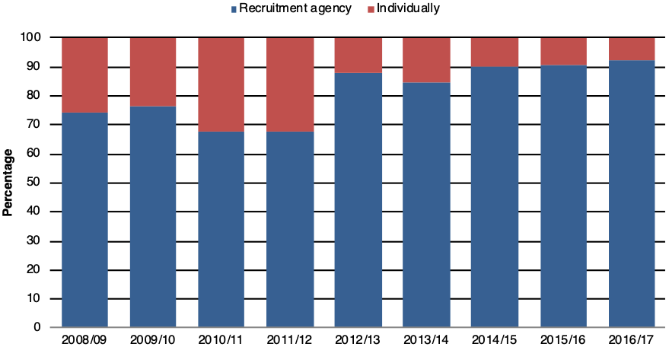
Source: Figure by the authors, based on the data obtained from the Government of Nepal, Ministry of Labour and Employment (2018).

In general terms, the inflow of immigrants in Portugal is tuned to the country’s employment rate. After the decrease in job offers following the financial crisis in 2008 and the consequent reduction in entries of immigrants, the rate of employment started to increase in 2011. This occurred especially in the intensive berry producing greenhouse farms, which had not significantly been affected by the crisis, and saw a substantial rise in the number of immigrants after 2013 (see Figure 2).
[Please insert near here figure 2]

With the rise of the employment offers increased the number of immigrants migrating to Portugal
Figure 2 Employment rate and migration inflows, Portugal, 2001-2016
‘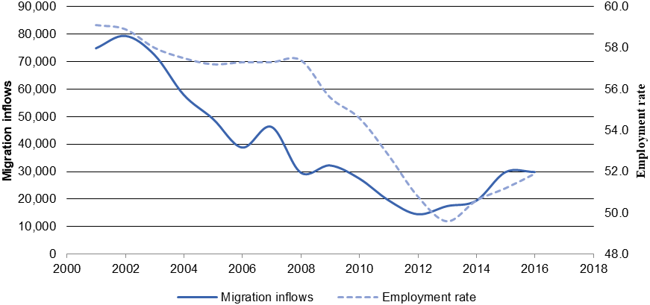 Source: Pires (2019), data obtained from Pordata (the employment rate) and the SEF (inflows).

The number of Nepalese migrating to Portugal accompanied this general trend: it increased since 2011/12 and the growth accelerated in 2013. In this specific case, we are discussing a recent immigration phenomenon from a country, Nepal, whose bilateral relations with Portugal are almost non-existent and with which there is no discernible prior history of migration. Although Nepalese immigration to Portugal is male-dominated (see Figure 3) the number of women inflow is quite significant. When comparing with immigrants coming from other origins, Nepalese have a significant dimension: in terms of total inflow they were the top 11th nationality in 2018 (OECD 2018).
[Please insert near here figure 3]

Nepalese migrating to Portugal: increase mainly since 2011/12
Figure 3 Inflow of Nepalese in Portugal by sex, 2000 to 2018
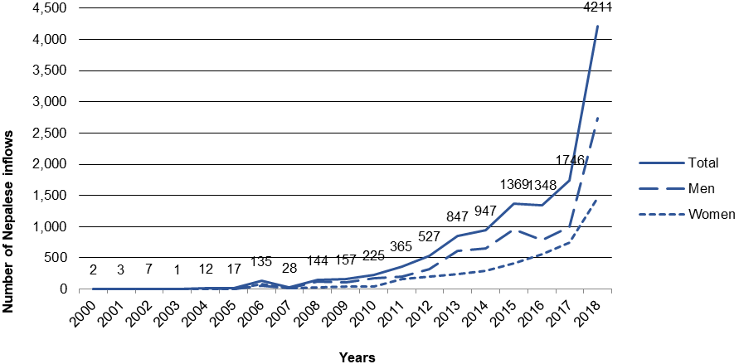 Source: Figure by the authors, based on data obtained from SEF (2018, 2019b).

The number of documented Nepalese residents in Portugal (in statistical terminology, ‘stock’) increased 903 percentage points in seven years; there were 1,145 Nepalese living in the country in 2011; after seven years, in 2018, the number increased to 11,489 (SEF 2012, 2018).
According to the last available Census of 2011, when there were still few Nepalese residing in Portugal, about one-quarter held an undergraduate university degree (26%) and nearly two-thirds completed secondary school (61%) (INE Portugal 2015). Although there is a risk that this data may be obsolete given the exponential growth of immigration since 2012, it still conforms to Gurung’s above-mentioned argument (2000), that Nepalese who migrate to Western Europe, are mainly higher-educated.
Regarding the geographical distribution in the destination country, Nepalese immigrants concentrate in Lisbon, followed by the districts of Faro (in Algarve, Portugal’s southernmost region) and Beja (in Alentejo, towards the South) (SEF 2019b). In Lisbon, the country’s capital, they are presently the third-largest foreign nationality, after Brazilians and Chinese (stock); between 2010 and 2016, the number of Nepalese living and working in Lisbon increased by 605 percentage points (Câmara Municipal de Lisboa 2018).
In Beja district, intensive greenhouse production of raspberries and blueberries is concentrated in the coastal municipality of Odemira. Of the 1,031 Nepalese residing in the district, 1,015 (i.e. 98%) live in Odemira (PORDATA 2019), an evidence that most Nepalese (and other immigrants) concentrate in this municipality. Data by district indicates that Nepalese were the top migrating nationality in 2018 in Beja (784), followed by Romanians (759), Indians (746), Thailandese (636) and Bulgarians (451) (SEF 2019b). Of all foreigners living in that district, the Nepalese are the third-highest represented nationality, the top nationality being Romanians (1279), followed by Bulgarians (1117), and then Nepalese (1031), Thailandese (851) and Indians (825) (SEF 2019b). Odemira is one of the top ten municipalities receiving the largest number of foreigners and the only one besides the Algarve, Lisbon and Oporto regions that provide a large labour market in tourism for immigrants (Oliveira and Gomes 2019, 59). The proportion of foreigners with a regular status among the total population (24,681) in Odemira was 25% in 2018 (Oliveira and Gomes 2019, 59).
Due to heavy international investment, Odemira was responsible in 2014 for the production of circa 90% of raspberries at the national level, the second most exported fruit, with a value of 64 million euros (Dias 2015). Exports of small fruits (raspberries, blackberries, blueberries, currants and others) reached 31 million euros in 2015, a figure that rose to180 million in 2018. This massive growth is a clear indicator of the potential of such crops, and of raspberries in particular, which were worth 153 million euros in exports (Vieira 2019). As the Portuguese representative of the world's leading redberry fruit company has recently noted, Southern Portugal, where Odemira is located, is the “California of Europe”; thanks to its mild climate and abundance of high-quality water, the two main reasons for the company to have made such a large investment there (Dias 2015).
The major changes in the rural landscape of Odemira was that the implementation of intensive farms, especially greenhouses relying in international investment, led a number of large companies to seek recruitment of cheap and flexible labour. Immigrants were the preferred choice, following the pattern set in other Southern European regions. This transformation concurs with the type of development in Southern European agricultural activity that developed at the end of the 20th century to supply Northern and Central European markets (cf. Pereira et al. 2016).

5. Materials and methods
We combined different approaches and methods, namely collection and analysis of quantitative/statistical indicators of migration with the qualitative-based ethnography – resorting to participant observation and semi-structured interviews. The approach used by the study was qualitative and interpretative to reach the deeper meanings related to the immigrants’ experiences and aspirations in order to better characterise the migration processes (cf. Bryman 2015). Ethnography seemed the most appropriate method since it is based on data gathered by the observation of daily actions and routines of the participants with a view to advance more abstract analyses and broader interpretations (cf. Wolcott 1990; Eder and Corsaro 1999).
We also collected and analysed statistical indicators from national, foreign and international sources on Nepalese migration to contextualise the ethnographic study’s results. At the national level, we collected data from the Immigration and Border Service (SEF) and the Institute of National Statistics (INE). Data collected from other sources focused on the UK’s Department of Work and Pensions and the Nepalese Ministry of Labour and Employment. The primary sources for comparative international data came from the Organisation for Economic Co-operation and Development (OECD), the International Labour Organisation (ILO) and the World Bank.
A total of 38 migrants were interviewed for the study, namely Nepalese agriculture workers (29) and recruiters (3), as well as Portuguese greenhouse owners, managers and recruiters (6). We used a non-probabilistic (snowball) sampling which is considered appropriate for gaining access to hard-to-reach or hidden populations (Noy 2008). Workers, recruiters, managers and owners of the greenhouses were interviewed with the aim to reach mutually complementary perspectives on the migration networks established between Nepal and Portugal. The interviews and participant observation were carried out in two periods: March and April 2017 and February to June 2018.
Interviews in Nepal were conducted in the capital city Kathmandu while interviews in Portugal were conducted in its capital — Lisbon, in Alentejo region—Odemira, São Teotónio and Zambujeira, and in the Algarve –Faro, Olhão, Luz de Tavira and Conceição. The interviews were made individually and generally lasted from one hour to one and a half-hour. Most Nepalese workers were interviewed either at home or during during social gatherings at cafes (considered more neutral locations than workplaces). Only in some cases they took place in the greenhouse settings (their workplace). We obtained written consent from each participant in the study guaranteeing anonymity and confidentiality of the testimonies.
The interviews were conducted either in English or in Nepali languages and later transcribed; the ones in Nepali were translated and directly transcribed into English. All were in-depth and semi-structured interviews with a number of guiding questions. Each case followed its own particular direction allowing us to delve into the difficult issue of the debts contracted by the migrants to pay the smugglers, information on the routes taken and countries crossed in their journey from Nepal to Portugal, the duration and the difficulties including risks they faced while in transit.
We analysed the interviews by codifying them into themes and used NIVO software for the thematic analysis. The broader and most relevant theme emerging from the analysis related to the transformation of aspirations during the migration process by comparing perceptions before having moved to Portugal and the experiences after arrival in the country. Extensive fieldnotes were taken during participant observation both inside and outside the greenhouse settings (in houses nd flats, in containers serving as dorms, in cafes and other public places during social gatherings). During fieldwork, the Nepalese workers often voiced to the Portuguese researcher concerns regarding the trying legalisation process in Portugal, as well as their psychological suffering due to accommodation issues (in some cases, up to 40 workers were living in a house suitable for three people). With the Nepalese researchers, the workers mostly shared the difficulties of repaying the huge debts incurred to migrate to Portugal.

6. Socio-demographic characteristics of the interviewees
To contextualise the findings of our research, we summarise the interviewees’ socio-demographic characteristics in the three tables below, referring respectively to the agricultural workers, the recruiters and the greenhouse managers and owners.
Most Nepalese farm workers (28 male and 1 female) were on an average young (29 years) and had 12 to 15 years of formal education (secondary school degree or bachelor’s degree). Only one female worker could be interviewed, a clear indicator of the gender imbalance in this particular migrant work set-up. About half of all the Nepalese farm workers interviewed were undocumented in Portugal and had paid on an average € 9.590 to reach Portugal. The interviewed workers earned € 521 gross revenue on an average which means they are formally underpaid since € 600 is the Portuguese legal minimum monthly wage.

Table 1. Socio-demographic characteristics of the Nepalese workers
Characteristics |  | Nepalese agricultural workers  (N=29)
Sex | Female | 1
Sex | Male | 28
Age | 21-30 years old | 17
Age | 31-40 years old | 10
Age | 41-50 years old | 2
Formal education level | Secondary | 19
Formal education level | Bachelor | 7
Formal education level | Master | 3
Money paid to migrate | 4001 - 6000 euros | 2
Money paid to migrate | 6001 - 8000 euros | 3
Money paid to migrate | 8001 - 10,000 euros | 15
Money paid to migrate | 10,001 - 12,000 euros | 6
Money paid to migrate | 12,001 - 14,000 euros | 3
Influence  in the decision to migrate, according to interviewee's responses | Recruitment organisation | 20
 | Friends | 11
 | Smugglers | 2
 | Family | 1
Documentation status | Documented | 16
Documentation status | Undocumented | 13
Average monthly wage in Portugal | 201 - 400 euros | 6
Average monthly wage in Portugal | 401 - 600 euros | 20
Average monthly wage in Portugal | 601 - 800 euros | 3
Average monthly wage in Nepal | 0 - 50 euros | 7
Average monthly wage in Nepal | 51 - 100 euros | 6
Average monthly wage in Nepal | 101 - 150 euros | 9
Average monthly wage in Nepal | 151 - 200 euros | 5
Average monthly wage in Nepal | 201 - 250 euros | 2
Source: Table by the authors, based on the interviews conducted during the research project.
All three labour recruiters interviewed (both Nepalese and Portuguese) were males with a medium to high level of education. Based on the data collected they were personally responsible for the recruitment of hundreds of Nepalese workers in recent years (100-300).
Table 2. Socio-demographic characteristics of the Nepalese recruiters
Characteristics |  | Nepalese recruiters  (N=3)
Sex | Female | 0
Sex | Male | 3
Age | 31-40 years old | 1
Age | 41-50 years old | 2
Formal education level | Secondary | 2
 | Bachelor | 1
Documentation status | Documented | 1
Documentation status | Undocumented | 2
Nr. Nepalese workers recruited | 1 - 100 | 1
Nr. Nepalese workers recruited | 101 - 300 | 2
Source: Table by the authors, based on the interviews conducted during the research project.

The managers and owners of the greenhouses interviewed were all Portuguese, three males and three females. They all had a medium to high level of education. The companies’ size varied widely across the spectrum which naturally reflect on the number of Nepalese workers employed in each (see table below).
Table 3. Socio-demographic characteristics of the Portuguese greenhouse managers and owners
Characteristics |  | Portuguese greenhouse managers and owners  (N=6)
Sex | Female | 3
Sex | Male | 3
Age | 31-40 years old | 3
Age | 41-50 years old |  | 2
Age | 51-60 years old | 1
Formal education level | Secondary | 1
 | Bachelor | 3
 | Master | 2
Business net worth | Up to 1 million euros | 2
Business net worth | 1 - 10 million euros | 3
Business net worth | More than 10 million euros | 1
Nr. Nepalese workers | 1 - 100 | 2
 | 101 - 300 | 2
 | More than 300 | 2
Source: Table by the authors, based on the interviews conducted during the research project.

7. Findings and discussion

“Families love if you go abroad” – Migration aspirations of the Nepalese
In response to their motivation to come to Portugal, one of the interviewees’, Janak, said: “In my [home] region, almost everyone is abroad. Mostly in Japan. If you don’t emigrate you’re a nobody”. Another interviewee, Raju, similarly said: “You know, our culture is an emigration culture; if you don’t migrate, you’re a nobody”. Both the ensuing conversations revealed that a combination of economical and cultural reasons motivated them to migrate. Although a better salary in Portugal than Nepal was important for them, i.e., economic reasons, these and other interviewees mostly had a middle-class background with few difficulties to live and raise a family in Nepal. Therefore, they migrated not only because they aspired for a better life but because they saw migration as a possibility of raising their social status given the respect that narratives of success related to emigration inspire, as the expression “if you don’t migrate, you’re a nobody” clearly shows i.e., cultural reasons. Secondly, the decision to migrate was not only based on individual choice, but family pressure played a key role, since the reception of remittances by migrants’ families is equated with higher social status than families without migrant members. Thirdly, “Europe” is represented as a “dream destination” with Portugal portrayed as a country where it is comparatively “easier” to obtain the necessary documentation to become a regular migrant, although as we will see later, it is only after arrival that immigrants start realising the difficulties in the legalization process and the risk of remaining in a limbo of statutory irregularity for long periods.
Aspirations, i.e., the desire to migrate based on economical and cultural reasons frequented in the interviews, for instance in the words of Subedi:
My father and mother don’t work, they are too old. My wife doesn’t work…. So, I have to help them. […] Families love if we go abroad, because that means we can help them. Our status also rises and people respect us more if we live abroad (Subedi, male, 43; our italics).
Subedi migrated to India, then to Denmark and to Portugal. He paid 7,000 euros for visa, resident permit and flight tickets by selling properties and taking loans from extended family members. In Nepal, he had secondary level of education and was a farmer, earning € 110 monthly i.e., nearly the double of the average monthly wage in Nepal (€ 59). In Portugal, as a farm worker, he earns between 300 euros and 500 euros monthly (depending on the season), well below the official minimum salary and he is undocumented. While he made it explicit that he was expected to “help the family”, Subedi also let it be understood that his decision to migrate was related to the expectation of success and consequently with a rise in his social status at home. This ambivalence was common to most interviews. It reveals how the economic motivations to migrate is socially oriented, in the sense that in addition to material gains, it relates to the need for approval and affirmation of status and power, all dependent on the opinion of others (Portes 1999, 8).
As Judith Hellman (2008) posits, cultural reasons play a concurring key role together with the economic reasons in the decision to migrate. This correlation was observed among male Mexican migrants in the USA who are both sponsored financially and encouraged culturally by their family, given that emigration is structural in the country, a situation that parallels that of Nepalese young males migrating to Portugal.
Related with the economical, social and cultural motivations playing key roles in the decision process to migrate is the interplay between structure and agency in aspiration, i.e., desire to migrate and the ability to concretise it. The decision may inevocably be one of individual agency but, according to Carling and Schewel (2017), when it is taken in an environment where everyone wants to leave, i.e., where emigration is structural, that individual decision is simultaneously an outcome of other individuals’ attitudes and actions. Carling and Schewel (2017) suggest that seeing aspiration from the point of view of agency and ability in terms of structural constraints and opportunities is limited because the reality is more complex:
The very notion of leaving – as an option that individuals can have an opinion about – is socially constructed. […] When we recognise the interplay of structure and agency in each step, the aspiration/ability approach can transcend the trap of extremes: either individualism or environmental determinism (14).
Nepal has high migration aspirations while the ability to migrate in concrete is low due to the restrictive policies of the destination countries. Its only open border is with India, whilst the other main destination countries have a closed borders policy (dependent on visas) towards Nepalese travellers (Carling and Schewel 2017, 6, 12 based in OECD data).
Our second finding demonstrates that the individual (micro-dynamic) decision to migrate is urged by the family, usually by the wife – agency –, motivated by aspirations for a better life (e.g., the result of comparing with neighbourhood women whose husbands have migrated, who have better houses and whose children attend private schools) and the subsequent social standing in Nepalese society (e.g., migrant husbands are well respected in the village) – structure.
I have a wife and one son back in Nepal. My family is a joint family type where my mother, father, brother, sister in law, wife and son live together in the same house. […] It was my own decision supported by my wife. She was also my motivation to go abroad, so that we, as a family, could have a better life. I arrived in Portugal in 2015. […] I was sponsored by another Nepali, in the Netherlands. But I didn’t know the guy who sent me the sponsorship as it was arranged with the help of my agent (Davendra, 32, male; our italics).
Davendra paid €6,500 to a recruitment agency to reach Portugal with a tourist visa since he couldn’t get a work visa from the Portuguese embassy in India. As Portugal doesn’t have an embassy in Nepal, migrants have to travel to India and pay the stay to apply for and then pick up the visa. In Nepal Davendra had a bachelor degree in business administration and worked as an accountant earning €92 per month, more than average monthly wage in Nepal (€ 59). In Portugal, he worked in a farm earning €580 a month except for the two months when there are no red fruit crops and he cannot find an alternative short term job. He fell into undocumented status after his request for a residence permit to the Immigration and Border Service (SEF) exceeded the response time and his request was put on hold.
The decision to migrate can also be motivated by the desire to escape the traditional family structure in Nepal. After marriage, the wife moves to the house of the husband’s parents and lives in an extended family along with the brothers-in-law and their respective wives. In Portugal, they can be “modern”, where both husband and wife may work, use European clothes and have more freedom from the nuclear family.
I want my wife to come, because when she comes here, she can work… there, she doesn’t work, and I have to feed five, six people alone… so, for us, it’s better if they [wives] come (Subedi, male, 43).
Our third finding was that whereas Europe is viewed as an opportunity for a better life, Portugal is primarily considered for supposedly offering migrants easy access to documented status. The reality immigrants face after arrival turns out to be very different from the expectations, namely concerning the extended periods of time it takes to become fully documented and the high costs of accommodation and food relative to the salary received.
I was a vetenary technician back in Nepal and I have worked for over six years. […] took help from a consultancy (agent) and came to Poland on a student visa. Then the opportunities and future in Poland was not as promising as I thought. I could not only study but was looking for work and become established in that country. It seemed like an impossible dream and then I heard a lot about Portugal. I finally decided to come to Portugal.
To be honest, the conditions are very bad. I didn’t even get 1% of my expectations, like European life, job respect and everything. It is nothing like that and the condition is worse. Talking about work I worked in the field when it was 45 degrees during summer. Normally, I worked for 12-13 hours a day.
I have spent 15,000 euros in total, 12,000 to come to Poland, then 2, 3 thousand to come to Portugal (Udip, male, 35; our italics).
Many Nepalese who come to Portugal expect farm work to be an opportunity for easy legalisation but labour exploitation is actually the norm for these workers.
I knew nothing about the country when I arrived… We just know it is the place in Europe to get the papers, that’s what they tell us [before coming] (Raju, male, 25).
The construction of this perception of Portugal since about 2011 coincides with the increasing difficulty to migrate to the UK due to the obstacles that the UK government contemporaneously erected to the entry of non-EU immigrants such as the Nepalese.

The barriers of the UK and the consequent rise of Nepalese in Portugal
A second important outcome of our research is that macro dynamics influence individual (micro) decisions to choose Portugal as a destination. Specifically, the obstacles posed in 2011 by the UK government to the contracting of immigrants from countries outside the EU, such as the Nepalese, in 2010/11 (cf. Sumpton 2019), a measure supposedly aimed at reducing immigration in that country, led the intermediaries (and traffickers) to look for alternatives in other European countries. Coincidently, the Portuguese economy, similar to other Southern European countries, suffered recession. Unemployed and underemployed Portuguese chose to migrate to the UK and other countries (namely Brazil and Angola) at the time that intensive agriculture farm owners and managers needed to expand their workforce. Since local Portuguese were not available due to unattractiveness of the salaries and conditions offered, the flow of Nepalese going to the UK began being redirected to the farming labour market in Portugal as the need for farm labor worked as a pull factor.
When considering the pull and push factors that influence migration flows, either from Nepal or elsewhere, it is clear that we must address macro, meso and micro dynamics and analyse their interplay. At a macro level, governmental immigration policies play a preponderant role in the regulation of the migration flows (Massey et al. 2002; Goldin, Cameron, and Blarajan 2011). For the present study, they clearly are relevant in the direction, dimension and fluidity of migrant flows.
As highlighted in Figure 4, the number of non-EU migrants entering the UK began decreasing around 2012 (UK Department for Work and Pensions 2019). In the rebound of the 2008 financial crisis, a renewed UK labour market and the need to comply with the pan-EU principle of free circulation of people led to a swell in variously qualified EU migrants’ entries, working in a plurality of sectors, e.g. industry, services, agriculture, education, health (Pereira 2019). This swell paralleled the introduction of a “closed doors” policy, barring the entry of new, generally non-qualified, migrants originating from non-EU countries.
[Please insert near here figure 4]
The decrease in the entry of non-EU migrants from 2012 onwards
Figure 4. Number of EU and non-EU immigrants inflows in the United Kingdom, 2002-2018
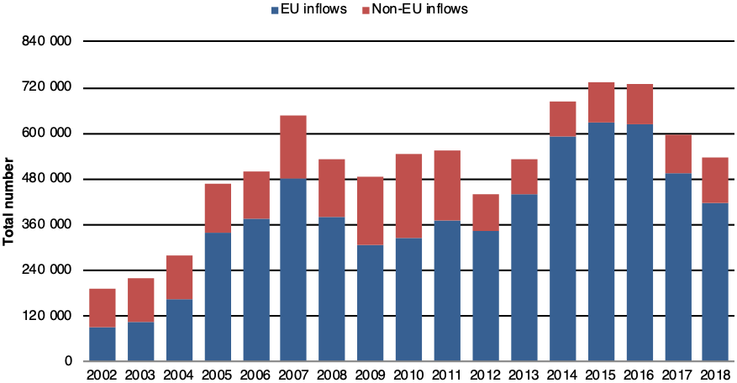
Source: Figure by the authors, based on the data obtained from the Department of Work and Pensions, 2019.
The volume of migration flows is not only influenced directly by immigration policies but also indirectly (Massey et al. 2002, 14). The steeming of the flow of non-EU migrants to the UK led to their redirection to other EU countries accounting for the contemporaneous increase in their number in Portugal and in other EU countries. As inflows to the UK started decreasing in 2011 they began increasing in Portugal, with a clear acceleration from 2013, coinciding with the growing rate of employment in the country (see Figure 5).

With the decrease of the Nepalese inflow to the UK from 2010/11 coincided the growth of the Nepalese entering in Portugal
Figure 5 Migration inflows of the Nepalese to the UK and Portugal, 2002-2018
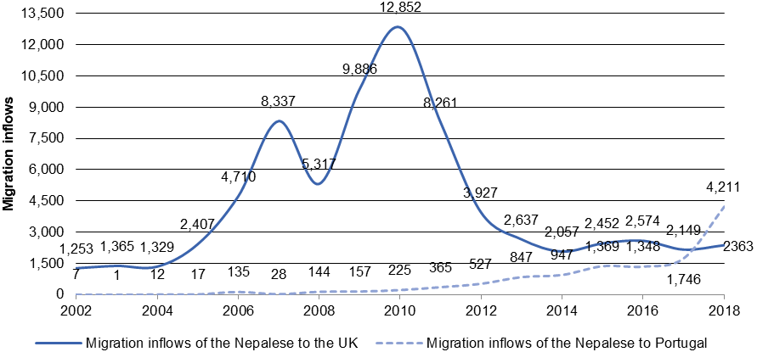
Source: Figure by the authors, based on data obtained from the Department of Work and Pensions, UK (2019), and SEF, Portugal (2018; 2019).

Some of the Nepalese interviewees admitted that either their or their friends’ ultimate aim, if ever successful in becoming fully documented in Portugal, would be to migrate to the UK. These stances need some deconstruction. In Sagar’s words:
Right now, we like Portugal. […] Well, Nepalese in Lisbon, some people tell me they want to go to the UK… and they often go - because they have some family in the UK. Well, now with the Brexit, not so much… (39, male).
Sagar had migrated from Nepal to South Korea then to Dubai and from there to Italy and finally to Portugal. He paid €9,000 to a Nepalese agency to migrate to Europe. He is now fully documented and earns €3,35 per hour (about €580 monthly) working in a greenhouse, although as per the Portuguese law (which he knows) he should be paid about €6.
This expressed desire to migrate to Great Britain compounds a stereotyped aspiration among the Nepalese. The UK is the top destination of the Nepalese in Europe (World Bank 2016, 192). The motivation to migrate to UK is cultural and practical: many Nepalese have family and friends living there, and benefiting from such networks to find a job is considered normal for migrants. As English is widely spoken in Nepal among the youth, they see migrating to the UK as the best option for countering the linguistic disenfranchisement they feel in non-English speaking EU countries. In Portugal, the language barrier is difficult to cross due to the few available Portuguese language courses for the foreigners that are compatible with the conditions they find themselves in: long working hours in non-urban areas and little contact with local co-workers. Lastly, given the pressure to repay the debts incurred to pay the smugglers for facilitating their journey to Portugal and to send remittances to families in Nepal, migrants find themselves in a bind: living on less than the Portuguese national minimum wage. Dreaming of migrating to the UK also means aspiring better salaries than in Portugal.

“My ‘friends’ told me to come here” – Migration recruitment networks and routes
The meso level of the migration decision-making process, in our research, means considering the role of formal (institutional) networks in the creation and development of the migration flow from Nepal. “State-supported or private labour recruiters help to initiate migrant flows by spreading (often limited) information about the destination country and offering jobs, accommodation, and support for potential migrants” (Goldin, Cameron, and Blarajan 2011, 105 our emphasis). Our third finding was that the decision of the interviewed Nepalese to leave their original home was reinforced by the meso dynamic role of both formal and informal networks of recruiters.
Due to the pan-EU migration restrictive policies towards third countries’ candidates, many Nepalese resort to illegal smuggling, ending up paying on an average €9,500 to recruitment and travel agencies. As few Nepalese can afford to pay this sum, the norm is to contract loans and mortgage property. As Janak, a farm worker in Odemira, puts it:
Sometimes it’s just the most rich guy in the village, he borrows money or gets fields and houses as a guarantee, so that other people can move abroad… many times it’s like that (male, 21).
Janak paid €11,000 for his journey to Portugal. Like many others, he comes from a rural middle class family and offered guarantees in properties to repay the debt incurred in the migration process. The poorer Nepalese choose India or the Gulf countries, a migrating route for which they may have to pay up to €5,000 (Gurung 2000). Upon arrival in Portugal, Janak filed his request at SEF for resident and work documentation but after months he is still waiting for an answer. Janak earns a monthly salary of €580 but at the time of the interview the Portuguese-owned company owed him three months’ back pay, a situation that added to the cycle of vulnerability he found himself in. The reliance of agricultural seasonal workers on agencies to get jobs in Portugal was also found in another study of the Fundamental Rights Agency (FRA 2019).

The migration trajectories followed by the Nepalese workers are diverse in nature and the migratory strategies chosen are varied – from safer, air and land, options to riskier ones, such as paying to local smugglers in Lybia to cross the Mediterranean in rubber dinghies or small wooden boats. Migrants resort to different travel schemes, frequently jumping to options based on hearsay stories of previous migrants. Although they are cheating the system, they are nevertheless vulnerable to being cheated themselves, namely by unscrupulous smugglers:
Many people are coming through Poland because it’s the easiest way now… but also others from Israel, Dubai…. Denmark, as we have many students there, in north ‎Europe… (Ram, male, 32).
I used help from an agent. I came on a tourist visa and he charged me around 8000 euros. But I had been scammed before by a different agency and I lost 5000 Euros in my first attempt. […] The only work of the agents was to get me to Europe anyhow. They made documentations and situations which was helpful for me to obtain a visa. I was supposed to attend a seminar in France. That is how I entered Europe (Shyam, 40, male).

We managed to identify the five main routes Nepalese migrants use to reach Europe and arrive in Portugal: through the Gulf and Turkey; through Central Europe (mainly Poland and Latvia, usually resorting to the assistance of smugglers and work agencies); via Libya – crossing the Mediterranean to Italy (resorting to local smugglers); from West European countries (The Netherlands, Denmark, the UK or Italy) normally after visas and work permits expired or were dismissed as non-valid; or flying directly from Nepal (with a short stop-over in the Emirates, and/or in Turkey).

Main routes to come to Portugal: Poland, Latvia and Turkey

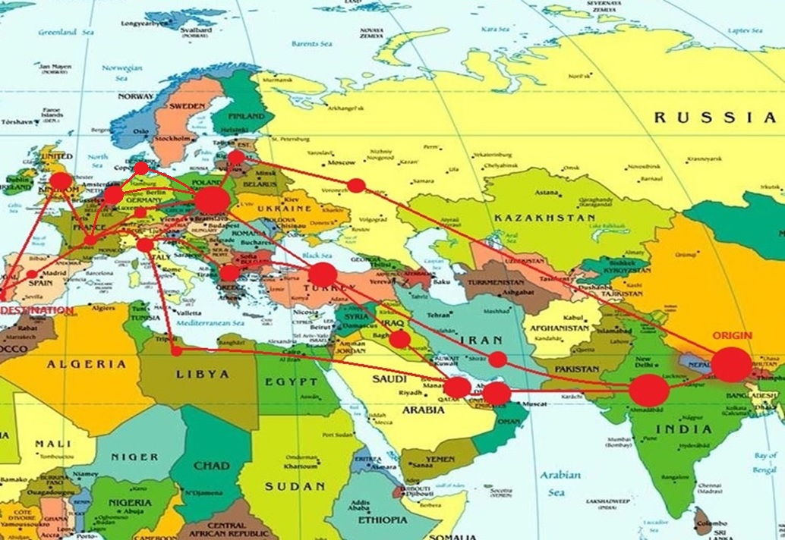
Figure 6 Routes of the Nepalese from Nepal till Portugal
Source: Figure by the authors, based on the data of the interviews.

The Polish route (that is, after a working stint there) is probably the most frequent one, or at least was during the period of our fieldwork. A Portuguese recruiter highlighted this and hypothesised on the reasons for the migrants to move to Portugal:
We have people knocking on our door to offer workers every week, and they pay for us to accept them! I must say, it’s very tempting! (…) Maybe one of the easiest countries to get in now, in Europe, is Portugal… and, I don’t know… some northern countries… like Poland. I can tell you that many workers are arriving here with Polish visas. Lots of them entered through Poland and then did not adapt there – due to climatic or cultural reasons, perhaps… (António, 48, male).
António’s company is owned by a Nepalese businessman with contacts with authorities in Nepal; they employ a marketing person in Lisbon who is well-informed about expected migrants’ arrivals, contacts them during transit or upon arrival in Portugal and refers them to farm owners and managers in the South.
On an average, agencies and intermediaries charge €9,500 and above to bring the Nepalese to Portugal. Migrants mainly pay these amounts by requesting informal loans (to intermediaries, or to family and “friends”), frequently subject to high interest rates. What some interviewees described as “friends” turn out to be agencies recommended to them by acquaintances – the “weak ties” that become “strong ties” who ease the mobility, in the words of Granovetter (1973). In the greenhouses, we collected dozens of discarded business cards that intermediaries from recruiting companies had offered to the Nepalese farm workers. These recruiters usually started by creating an agency, registered as “service provider company” (and not as “temporary work”) and after a couple of years closed the first company to open a new one, with a different name, with the obvious purpose of deluding authorities and avoiding payment of due fees or taxes.

“We never expected these conditions” – Experiences of the Nepalese working in Portuguese agriculture
A major finding of our study relates to the changing aspirations of the Nepalese rural workers interviewed in Portugal. Almost all of our respondents confirmed that they hadn’t expected the difficulties they find themselves in and the reality they face is disparate from their initial aspirations. The exploitative labour situation, the job precariousness and the roughness of the housing conditions were found to be drastically worse than they had imagined. Also, the labyrinthic legalisation process, the debt repayment and the path for family reunification take much longer than they had anticipated.
But not all is negative and grim in their experience as immigrant workers in Portugal. Among the positive aspects the Nepalese interviewees highlighted were, what they referred as, the pleasure of watching the “modernity” in the Portuguese way of dressing (the implicit suggestion being that they were thinking of Portuguese women), enjoying freedom away from the family, the possibility of trying new hair cuts and, whenever possible, strolling in town and visiting tourist landmarks. They looked forward to bringing their wives and children to Portugal so that they could also experience the life there.
Most of the Nepalese workers we interviewed had made the journey to Portugal by contracting intermediary recruitment agencies. The payment regularly covered food and lodging along the route, acquiring a temporary work visa either in Portugal or another EU-member country, flight expenses and early housing costs in Portugal.
Concerning acquiring a resident permit, the typical procedure in Portugal tends to be excruciatingly slow: after submitting the initial request applicants are likely to experience an extended waiting period (from an ideal minimum of five months to up to three years, currently), punctuated by multiple appointments and interviews at SEF’s Immigration Offices, during which the applicant is usually requested to produce a number of additional documents. They must provide proof of work or a job contract as well as proof of legal entrance in Portugal. About half of our interviewees were non-documented until the end of the fieldwork period. This led to constant feelings of frustration:
When I arrived in Portugal, I had to pay 27 euros in three months to the company, after working for them for three months! So embarrassing! (…) I got my residence card only in December 2016, when it had already been sent in October 2016. I had given the address of this [employer] guy, but he didn’t receive it for me. (Dinesh, 25 male).
The workers described to us multiple worries relating to job and housing conditions and with work environment. Housing conditions and the monthly cost of a single bunk bed (frequently inside a metal container) were one of the main qualms of the Nepalese interviewees. We witnessed various situations of crowded housing, such as up to 40 people sharing a three-bedroom house, overcrowded containers and crowded interior bedrooms where 18 Nepalese workers were packed, usually resorting to rotating bedtimes. Sleeping inside the containers during the Summer (when temperatures often reach 45ºc / 113ºf) was described as particularly being difficult, as the miniature top barred windows wouldn’t allow for air circulation. Drinking water or sewage systems were frequently unavailable.
We are like dogs here: a dog’s life. Nobody cares. (…) I worked in Évora, Beja, Comporta. We lived not in containers there, but where they put the cattle inside [stables]. (Chetan, 28, male)
The work I am involved in is entirely different that I thought. I had never done any agricultural work in my life before. In Nepal, only uneducated and poor people get involved in farm work unless it is their own farms. I hide my current job position to his family and only my wife knows that I work in a farm. I never imagined a life like this. It is a matter of shame and I don’t tell my family that I am working in the agriculture farms (Davendra, 32, male)
I had great positive expectations about my life in Europe but the reality was completely different and I only knew it when I was here. I thought I would do better than Nepal, have more income and be settled. But as I said, reality is really different (Udipi, 35, male).
Still, the Nepalese workers and recruiters we interviewed reported a diversity in experiences and profiles which account to important variations in how the migratory process is lived and perceived and how success may be measured. Such multiple realities contradict the outside perception that Nepalese share a monolithic view of their life in Europe and provide evidence for multiple levels of exploitation in the dynamic panorama of intensive agriculture in Southern Portugal. Nevertheless, we should stress that the “institutionalisation of exploitation”, be it at the origin, in intermediary countries and at the destination, as well as the social capital involved (migrant “networks” and “contacts”) play a major role in the process of international recruitment of migrant rural workers. Furthermore, our data clearly talks of a “naturalisation of exploitation” by these workers. This “naturalisation” is a way for migrants to cope with the harsh conditions they face which helps in resilience building, allowing them to psychologically deal with the transformation of their initial aspirations and adapt. It also facilitates the acceptance of persistent exploitation and abusive realities perceived by the immigrants as unquestionable “necessary steps” in the long ordeal to acquire a residence permit in Europe and eventually achieve the long-term goal of family reunification.

8. Conclusions
Nepalese migration to Portugal originates from a country with high outflow rates, consolidated family emigration traditions and an intense dependence on remittance transfers. In the recent past, the migratory predisposition took advantage of the diffusion of English as a second language among most of its inhabitants, particularly the more educated. The barriers to immigration from third countries, implemented by the last British governments, have prompted the search for alternative routes. The fate of Portugal, which emerged from this search made by networks of smugglers of migrants, with access to information that migrants do not have, is paradoxical: language is an obstacle to integration and wages are much lower than in other European countries. There are, however, four comparative advantages in the destination Portugal: a demand for migrant work for situations close to the migrant enclave, which is poorly qualified and therefore not very demanding in terms of communication; greater ease in working undocumented due to the persistence of weakly regulated sectors of the labour market; a legal framework that facilitates the regularisation of undocumented migrant workers; and, finally, lower living costs than in alternative destinations that partially compensate for low wages.
Although the Nepalese interviewed present diverse profiles, a significant dimension belongs to the middle class in Nepal, with qualifications. They are not integrated into Portuguese society, since they are undocumented and do not speak Portuguese - the two basic principles of integration. They present descending professional mobility since the majority worked in services and in Portugal they work in agriculture. Simultaneously, the Nepalese enjoy consuming the “modernity” in Portugal, e.g., concerning the way of dressing, as well as a new lifestyle where they enjoy more freedom compared to Nepal.

The presence of Nepalese immigrant farm workers in the coastal rural regions of Southern Portugal is a new and understudied phenomenon. Their existence is frequently acknowledged in the national and local media, and news about the dire conditions they experience in intensive berry greenhouse farms is often shared. The locals, apart from the farm owners, managers and co-workers, and people servicing in cafés, supermarkets and administrative offices (namely, immigration and social security), have little knowledge and opinion about them. Since the Nepalese seldom leave greenhouse environments and very few of them speak Portuguese, they are socially nimble and are viewed as untroublesome foreigners with no reason to empathise or interact with.
And theirs is a dire experience as migrants in a foreign country with a culture and language mostly inaccessible to them. They live and feel isolated in closed settings in which their hard labour is overexploited, underpaid and easily expendable, and their human and cultural needs are unmet. They lodge in pitiful conditions, their mobility is thwarted, their religiosity is unrecognised, and their language and values are uncomprehended, an enormous transformation in the aspirations of the Nepalese who did not, even remotely, expect such outcomes. In their experience, legalization, repayment of debts and family reunification took much longer and work, wage and housing conditions were considerably precarious than expected.
But they still come and they persevere. Their aspirations to migrate for a better life and the restrictive immigration policies contributes to naturalise the debts contracted for migration and labour exploitation. Associated with the high migration costs and extended repayment periods with high-interest rates, we must underline the observed “institutionalisation of exploitation” in Europe –seen as natural and normal by a majority of our Nepalese interviewees.
Many Nepalese migrants in Portugal are caught in a Catch 22 situation: once they took the migration route, indebted themselves, were sent off their villages and towns with a mission to succeed, they cannot go back. They cannot go forth either: the ultimate aspiration would be to get better salary in a country with extant Nepalese community and where they can use a relatively comfortable language: English. Though, Brexit, as the previous obstacles in 2011 to non-European entering the UK, challenges their intention of moving to England.
So, they feel as they live in a limbo, and although they are conscious of the exploitative situation they are in, they find ways to build resilience.

References
Bajracharya, Manika. 2015. “Nepalese Women Migrants in Portugal and Their Experience with Socio-Cultural Integration.” Instituto Universitário de Lisboa, ISCTE. https://repositorio.iscte-iul.pt/handle/10071/10346.
Blau, Peter M. 1977. Inequality and Heterogeneity: A Primitive Theory of Social Structure. New York: The Free Press.
Boudon, Raymond. 2003. Raison, Bonnes Raisons. Paris: PUF.
Branco, Inês Miradouro. 2012. “A Língua Portuguesa e Os Média Nas Vivências De Imigrantes Nepaleses Em Portugal [The Portuguese Language and the Media in the Experiences of Nepalese Immigrants in Portugal].” Revista Comunicando 1 (1): 66–88.
Bryman, Alan. 2015. Social Research Methods. 5th ed. Oxford: Oxford University Press.
Budal, Aashima. 2018. “Paperless Reality: Transnational Parenthood and Undocumented Nepalese Immigrants in Portugal.” Instituto Universitário de Lisboa, ISCTE.
Câmara Municipal de Lisboa. 2018. Plano Municipal Para a Integração de Imigrantes de Lisboa 2018-2020 [Municipal Plan for the Integration of Immigrants of Lisbon 2018-2020]. Lisboa: Câmara Municipal de Lisboa, Pelouro da Educação e dos Direitos Sociais.
Carling, Jørgen, and Kerilyn Schewel. 2017. “Revisiting Aspiration and Ability in International Migration.” Journal of Ethnic and Migration Studies, October, 1–19. https://doi.org/10.1080/1369183X.2017.1384146.
Carmo, Renato Miguel, and Charlotta Hedberg. 2019. “Translocal Mobility Systems: Social Inequalities and Flows in the Wild Berry Industry.” Geoforum 99: 102–10. https://doi.org/https://doi.org/10.1016/j.geoforum.2018.12.002.
Castles, Stephen. 2000. Ethnicity and Globalization: From Migrant Worker to Transnational Citizen. London: Sage.
Dahal, Sanjeev. 2016. “Perception and Practice of Gender among Nepalese in Portugal. A Male Perspective.” ISCTE, Instituto Universitário de Lisboa.
Dangol, Abhas. 2015. “Parenting among Nepalese Families in Lisbon and Its Effect on Child Integration.” Instituto Universitário de Lisboa, ISCTE.
Department for Work and Pensions. 2019. “NINO Registrations to Adult Overseas Nationals Entering the UK.” Stat-Xplore Department for Work and Pensions. 2019. https://stat-xplore.dwp.gov.uk/webapi/jsf/login.xhtml.
Dias, Carlos. 2015. “Cerca de 90% Da Produção Nacional de Framboesa Concentra-Se Na Zona de Odemira.” Público, June 30, 2015. https://www.publico.pt/2015/06/30/local/noticia/cerca-de-90-da-producao-nacional-de-framboesa-concentrase-na-zona-de-odemira-1700499.
Eder, Donna, and William Corsaro. 1999. “Ethnographic Studies Of Children and Youth: Theoretical and Ethical Issues.” Journal of Contemporary Ethnography 28 (5): 520–31. https://doi.org/10.1177/089124199129023640.
Faist, Thomas. 2000. The Volume and Dynamics of International Migration and Transnational Social Spaces. Oxford: Oxford University Press.
FRA, European Union Agency for Fundamental Rights. 2019. Protecting Migrant Workers from Exploitation in the EU : Boosting Workplace Inspections. Luxembourg: Publications Office of the European Union. https://doi.org/10.2811/93816.
Giménez Romero, Carlos. 1991. “Trabajadores Extranjeros En La Agricultura Española: Enclaves e Implicaciones.” Revista de Estudios Regionales, no. 31: 127–48.
Goldin, Ian, Geoffrey Cameron, and Meera Blarajan. 2011. “Leaving Home: Migration Decisions and Processes.” In Exceptional People. How Migration Shaped Our World and Will Define Our Future, 97–120. Princeton: Princeton University Press.
Government of Nepal, Ministry of Labour and Employment. 2018. Labour Migration for Employment. A Status Report for Nepal: 2015/2016-2016/2017. Kathmandu: Government of Nepal.
Granovetter, Mark. 1973. “The Strength of Weak Ties.” American Journal of Sociology 78 (6): 1360–80. https://doi.org/10.1086/225469.
Gurung, Ganesh. 2000. Patterns in Foreign Employment and Vulnerability of Migrant Workers. Kathmandu: Nepal Institute of Development Studies.
Hellman, Judith. 2008. The World of Mexican Migrants: The Rock and the Hard Place. New York: The New Press.
Helweg, A.W. 1987. “Why Leave India for America? A Case Study Approach to Understanding Migrant Behaviour.” International Migration 25 (2): 165–78. https://doi.org/10.1111/j.1468-2435.1987.tb00578.x.
Hoggart, Keith, and Cristóbal Mendoza. 2000. “African Immigrant Workers in Spanish Agriculture.” 2. Working Paper CCIS. The Center for Comparative Immigration Studies. San Diego. https://doi.org/10.1111/1467-9523.00123.
ILO Country Office for Nepal. 2017. Nepal Labour Market Update. Kathmandu: International Labour Organisation (ILO).
ILO, International Labour Organisation. 2016. “Average Monthly Earnings of Employees (Local Currency).” Countries. Key Statistics. 2016.
INE Portugal. 2015. “Censos de 2011 [2011 Census].” Lisboa: Instituto Nacional de Estatística.
Kasimis, Charalambos. 2005. “Migrants in the Rural Economies of Greece and Southern Europe.” Migration Information Source.
Kharel, Dipesh. 2016. “From Lahures to Global Cooks: Network Migration from the Western Hills of Nepal to Japan.” Social Science Japan Journal 19 (2): 173–92. https://doi.org/10.1093/ssjj/jyw033.
Kilkey, Majella, Ania Plomien, and Diane Perrons. 2014. “Migrant Men’s Fathering Narratives, Practices and Projects in National and Transnational Spaces: Recent Polish Male Migrants to London.” International Migration 52 (1): 178–91. https://doi.org/10.1111/imig.12046.
King, Russell, and Daniela DeBono. 2013. “Irregular Migration and the ‘Southern European Model’ of Migration.” Journal of Mediterranean Studies 22 (1): 1–31.
Lauwe, P.H. Chombard de. 1971. Pour Une Sociologie Des Aspirations. Paris: Gonthier.
Liechty, Mark. 2003. Suitably Modern: Making Middle-Class Culture in a New Consumer Society. New Jersey: Princeton University Press.
Maharjan, Rojika. 2018. “The Intermediate Generation: Integration of Young Nepalese Immigrants in Portugal.” ISCTE-IUL.
Martin, Philip. 2017. Merchants of Labor - Recruiters and International Labor Migration. Edited by Oxford University Press. Oxford University Press.
Massey, Douglas S., Joaquin Arango, Graeme Hugo, Ali Kouaouci, Adela Pellegrino, and J. Edw Taylor. 1993. “Theories of International Migration: A Review and Appraisal.” Population and Development Review 19 (3): 431–66.
Massey, Douglas S., Joaquín Arango, Graeme Hugo, Ali Kouaouci, Adela Pellegrino, and J. Edward Taylor. 2002. Worlds in Motion: Understanding International Migration at the End of the Millenium. Oxford: Oxford University Press.
Morén-Alegret, Ricard, Sandra Fatorić, Dawid Wladyka, Albert Mas-Palacios, and Maria Lucinda Fonseca. 2018. “Challenges in Achieving Sustainability in Iberian Rural Areas and Small Towns: Exploring Immigrant Stakeholders’ Perceptions in Alentejo, Portugal, and Empordà, Spain.” Journal of Rural Studies 64 (November): 253–66. https://doi.org/10.1016/j.jrurstud.2018.05.005.
Moreno, Luís, Alina Esteves, and Maria Lucinda Fonseca. 2016. “Opções Empresariais , Agricultura e Contingências Laborais No Sul de Portugal : O Caso de Odemira No Contexto Da Mundialização.” In Smart and Inclusive Development in Rural Areas Book of Proceedings of the 11th Iberian Conference on Rural Studies Editors, 663–69. Vila Real: Universidade de Trás-os-Montes e Alto Douro (UTAD).
Noy, Chaim. 2008. “Sampling Knowledge: The Hermeneutics of Snowball Sampling in Qualitative Research.” International Journal of Social Research Methodology 11 (4): 327–44. https://doi.org/10.1080/13645570701401305.
OECD. 2018. International Migration Outlook 2018. Paris: OECD Publishing. https://doi.org/https://doi.org/10.1787/migr_outlook-2018-en.
Oliveira, Catarina Reis, and Natália Gomes. 2019. Indicadores de Integração de Imigrantes. Relatório Estatístico Anual 2019. Lisbon: Observatório das Migrações. https://doi.org/10.1080/09612025.2015.1007639.
OTSH. 2018. Tráfico De Seres Humanos. Relatório de 2017 [Trafficking in Human Beings. Report 2017]. Barcarena: Ministério da Administração Interna, Observatório do Tráfico de Seres Humanos (OTSH).
Peixoto, João. 2009. “New Migrations in Portugal: Labour Markets, Smuggling and Gender Segmentation.” International Migration 47 (3): 185–210. https://doi.org/10.1111/j.1468-2435.2009.00528.x.
Pereira, Alexandra. 2019. “Transborder Himalaya: Processos de Transnacionalismo Nos Empresários e Trabalhadores Nepaleses Em Lisboa [Transborder Himalaya: Processes of Transnationalism in Nepali Entrepreneurs and Workers in Lisbon].” ISEG, OpenSoc Programa de Doutoramento Inter-universitário. http://hdl.handle.net/10400.5/18150.
Pereira, Cláudia. 2019. “A New Skilled Emigration Dynamic: Portuguese Nurses and Recruitment in the Southern European Periphery.” In New and Old Routes of Portuguese Emigration: Uncertain Futures at the Periphery of Europe, edited by Cláudia Pereira and Joana Azevedo, 97–121. Cham: Springer International Publishing. https://doi.org/10.1007/978-3-030-15134-8_5.
Pereira, Sónia, Luís Moreno, Ana Estevens, Aline Esteves, and Jorge Malheiros. 2016. “Reconfiguración de Áreas Rurales y Explotación de Mano de Obra Inmigrante: El Caso de Odemira, Portugal [Reconfiguration of Rural Areas and Exploitation of Immigrant Labour: The Case of Odemira, Portugal].” Estudios Migratorios Latinoamericanos 30 (81): 227–50.
Piore, Michael J. 1979. Birds of Passage. Migrant Workers and Industrial Society. New York: Cambridge University Press. https://doi.org/10.1017/CBO9780511572210.
Pires, Rui Pena. 2003. Migrações e Integração. Teoria e Aplicações à Sociedade Portuguesa. Oeiras: Celta Editora.
———. 2019. “Portuguese Emigration Today.” In New and Old Routes of Portuguese Emigration: Uncertain Futures at the Periphery of Europe, edited by Cláudia Pereira and Joana Azevedo, 29–48. Cham: Springer International Publishing. https://doi.org/10.1007/978-3-030-15134-8_2.
PORDATA, INE/SEF/MAI. 2019. “População Estrangeira Com Estatuto Legal de Residente: Total e Por Algumas Nacionalidades - 2018.” PORDATA Base de Dados de Portugal Contemporâneo. 2019. https://www.pordata.pt/Municipios/População+estrangeira+com+estatuto+legal+de+residente+total+e+por+algumas+nacionalidades-101.
Portes, Alejandro. 1999. Migrações Internacionais: Origens, Tipos e Modos de Incorporação [[International Migration: Origins, Types and Modes of Incorporation]]. Oeiras: Celta Editora.
Reyneri, Emilio. 2003. “Immigration and the Underground Economy in New Receiving South European Countries: Manifold Negative Effects, Manifold Deep-Rooted Causes.” International Review of Sociology 13 (1): 117–43. https://doi.org/10.1080/0390670032000087023.
Rye, Johan Fredrik. 2018. “Labour Migrants and Rural Change: The ‘Mobility Transformation’ of Hitra/Frøya, Norway, 2005–2015.” Journal of Rural Studies 64 (November 2017): 189–99. https://doi.org/10.1016/j.jrurstud.2017.12.003.
Salt, John. 1987. “Comparative Trends in International Migration Study.” International Migration 25 (3): 241–50.
SEF. 2012. “Relatório de Imigração, Fronteiras e Asilo - 2011 [Report of Immigration, Borders and Asylum - 2011].” Oeiras. http://sefstat.sef.pt/Docs/Rifa_2011.pdf.
———. 2018. Relatório de Imigração, Fronteiras e Asilo 2017 [Report on Immigration, Borders and Asylum]. Oeiras: Serviço de Estrangeiros e Fronteiras (SEF).
———. 2019a. Relatório de Imigração, Fronteiras e Asilo - 2018 [Report of Immigration, Borders and Asylum - 2018. Barcarena: Serviço de Estrangeiros e Fronteiras (Immigration and Borders Service).
———. 2019b. “SEFSTAT.” Portal de Estatística. 2019. http://sefstat.sef.pt/evolucao.aspx.
Suleman, Fátima, and Maria da Conceição Figueiredo. 2018. “Wage Differentials within a Female-Dominated Occupation: Domestic Workers in Informal and Flexible Jobs in Portugal.” International Labour Review 157 (1): 129–52. https://doi.org/10.1111/ilr.12065.
Sumpton, Madeleine. 2019. “Briefing. Work Visas and Migrant Workers in the UK.” In The Migration Observatory. Oxford: The Migration Observatory.
Taboadela, Obdulia, María Maril, and Carmen Lamela. 2018. “La Superdiversidad Migratoria En El Medio Rural: Odemira, Alentejo, Un Estudio de Caso.” Finisterra 53 (107): 87–105. https://doi.org/10.18055/finis11935.
Vieira, Luís Medeiros. 2019. “Exportações: Os Pequenos Frutos São Os Maiores.” Frutas, Legumes e Flores. 2019. https://www.flfrevista.pt/2019/06/exportacoes-os-pequenos-frutos-sao-os-maiores/.
Wolcott, Harry F. 1990. “Making A Study ‘More Ethnographic.’” Journal of Contemporary Ethnography 19 (1): 44–72. https://doi.org/10.1177/089124190019001003.
World Bank. 2016. Migration and Remittances Factbook 2016. Washington, DC: World Bank.
———. 2019. “Personal Remittances, Received (% of GDP).” Estimates Based on IMF Balance of Payments Data, and World Bank and OECD GDP Estimates. The World Bank. 2019.

For the Master thesis and this study.
Concerning the Nepalese who migrate to Portugal with university degree, there is no segmented available information on the ones who come from rural areas and the ones from urban areas.
The top nationalities immigrating to Portugal are, by dimension of magnitude: Brazilian, French, Italians, British, Chinese, Romenian, Spain, Cape Verde, German and Angolan (OECD 2018).
It is worth noting that Odemira, like the remaining territory of Portugal, experienced a decrease of population between 2010 (26,138) and 2018 (24.681), due to the aging population. Nevertheless, it increased the number of foreigners, which means that if not for the foreigners the reduction of population would have been much bigger.
All the names of the interviewees are pseudonyms.
The middle class in Nepal is characterised in a relational mode (they are between those above and below, for example, in terms of salary) and by being consumers, in a context of capitalism and modernity that is disseminated on TV and social networks, such as the Western fashion (Liechty 2003). In this study, respondents earned in Nepal twice or three times the average wage and all have secondary or higher education.
The average monthly salary in Nepal in 2016 (ILO 2016).

